Study Guide for September 19th test
7th and 8th Grade

Where is a key signature found in music? And What does a key signature tell you?
A key signature is found at the beginning of music between the clef sign and time signature. The key signature tells you which notes are flat, sharp or natural in the whole song.
Key Signature
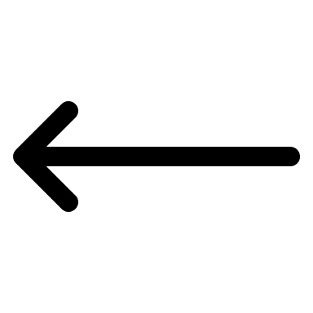
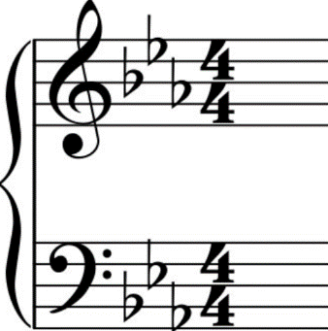

What is the difference between a slur and a tie?
A slur is a curved line that connects notes with different note names. It is played by tonguing/articulating the first note and slurring to the others without articulating.
A tie is a curved line that connects notes of the same sound/name. It is played by articulating the first note and sustaining the rest for the full duration of both notes.

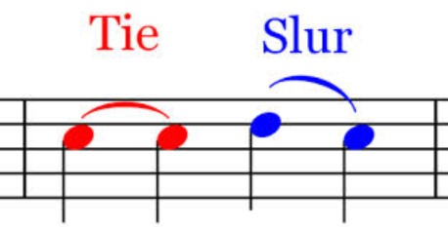

What is an accidental?
Sharp, Flat, Natural

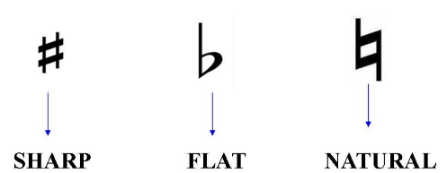

When an accidental is found in a measure, does it affect all notes?
No, an accidental only affects the note it is on and any after the note that are the same note name in the same measure. Once the measure is over that accidental is over.
